TASK 5: COMPLEX ANALYTICAL SQL QUERIES
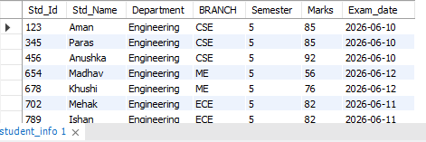
Objective: Write SQL scripts using Window Functions (ROW_NUMBER, DENSE_RANK, LAG, LEAD) and Common Table Expressions (CTEs) for advanced data analysis.
Sample Student Schema :

1. ROW_NUMBER(): ROW_NUMBER() assigns a unique sequential number to each row within a specified partition.
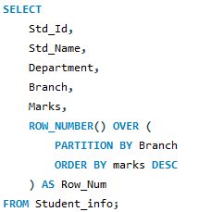
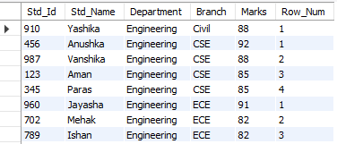
Query:

Assigns a unique sequential number to students within each branch based on marks.
2. DENSE_RANK(): DENSE_RANK() assigns the same rank to students with equal marks and does not skip ranks.
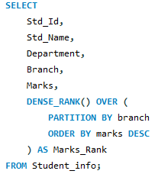
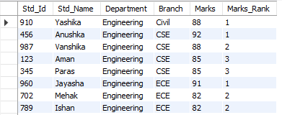
Query:

Ranks students within each branch based on marks, assigning the same rank to students with equal marks.
3. LAG(): Retrieves the value from the previous row within a group.
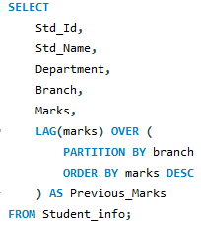
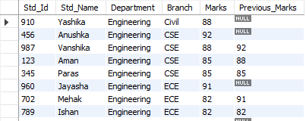
Query:

Displays the previous student's marks within each branch for performance comparison.
4. LEAD(): LEAD() retrieves the value from the next row within a partition.
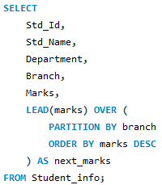
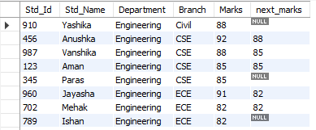
Query:

Displays the next student's marks within each branch for performance comparison.
5. CTE — Common Table Expression: A CTE is a temporary named result set created using the WITH keyword. It makes complex SQL queries easier to read and manage.
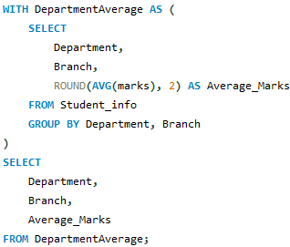
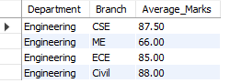
Query:

Calculates and displays the average marks for each branch.
6. CTE + DENSE_RANK() — Combined Query
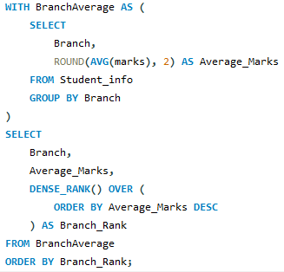
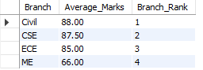
Query:

Combines a CTE with DENSE_RANK() to rank students within each branch based on their marks.

